

**Name: Basit Iqbal**

**Reg No: FA21-BSE-050**

**Class: BSE-4B**

**Submitted To: Sir Mukhtair Zamin**

**Date: 23/05/2023**

Object Oriented Software Engineering



**MAIN SUCCESS SCENERIO:**

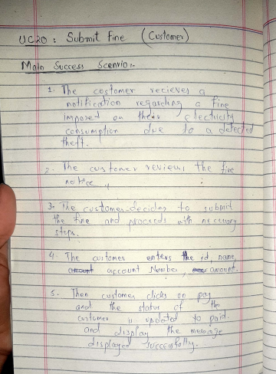

**SYSTEM SEQUENCE DIAGRAM:**

